[INSERT CENTER LOGO HERE]
MEDIA CONTACT
[First and last name]
[Direct phone number]
[Direct email address]

[CENTER] Performs [MILESTONE, EXAMPLE “5th”] Procedures Using EXALT™ Model D Single-Use Duodenoscope
EXALT Model D was the first single-use duodenoscope for use in procedures treating diseases of the pancreas and bile ducts.
[CITY, STATE]—[DATE]—[CENTER] today announced it has performed its [MILESTONE] procedure using the EXALT™ Model D Single-Use Duodenoscope — the first commercially-available single-use duodenoscope for use in endoscopic retrograde cholangiopancreatography (ERCP) procedures. The EXALT Model D Duodenoscope was developed as an alternative to reusable duodenoscopes, eliminating the need for reprocessing and repairs, allowing physicians to use a new, sterile device for every procedure.
Duodenoscopes are used in ERCP procedures to diagnose and treat various pancreatic and biliary conditions, and every year more than 500,000 ERCP procedures are performed in the U.S. and more than 1.5 million are performed worldwide.
PROPOSED Physician QUOTE
“Treating [Insert # of patients] patients with the EXALT Model D Duodenoscope is an important milestone for us as we continue to implement the latest and most innovative technologies with an aim to improve safety for patients in the [CITY/TOWN] area,” said [DOCTOR, TITLE, CENTER]. “Reliable single-use devices are a critical component of any endoscopy practice, and the EXALT Model D Single-Use Duodenoscope allows us to begin every procedure with a brand new, sterile scope, eliminating the inherent potential risk of cross contamination from ineffective reprocessing. This truly is a game changer.”
Unlike single-use devices, reusable duodenoscopes require a rigorous disinfection process between uses in different patients. While most procedures with these devices are carried out safely and effectively, there have been a small number of cases in which infections have resulted from use of contaminated devices, despite adherence to established protocols. As a result, the FDA has recommended that providers transition to duodenoscopes with disposable components or fully disposable devices, when they are available.
The EXALT Model D Single-Use Duodenoscope builds on the familiar design of standard reusable duodenoscopes, and in a voluntarily conducted case study series of the EXALT Model D Duodenoscope, Boston Scientific found that expert endoscopists were able to complete ERCPs across a wide range of complexity using the single-use duodenoscope.
The EXALT Model D Duodenoscope is currently being used in many leading endoscopy practices throughout the United States and around the world.
About [CENTER]
[INSERT PRACTICE BOILERPLATE]
For more information, visit [PRACTICE WEBSITE] or https://www.bostonscientific.com/en-US/medical-specialties/gastroenterology/exalt.html.
SUGGESTED IMAGE
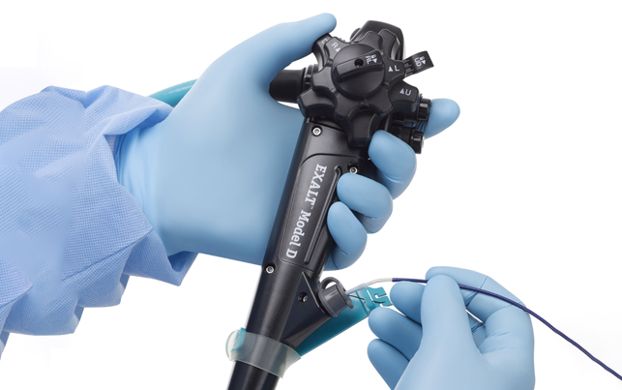

United States Food and Drug Administration website: "Infections Associated with Reprocessed Duodenoscopes" August 29, 2019.
Boston Scientific Internal Estimate
United States Food and Drug Administration website: " The FDA is Recommending Transition to Duodenoscopes with Innovative Designs to Enhance Safety: FDA Safety Communication" April 10, 2020
Muthusamy, V. Raman et al. Clinical evaluation of a single-use duodenoscope for endoscopic retrograde cholangiopancreatography. Clinical Gastroenterology and Hepatology, 2019, 0,0 Results from case studies are not necessarily predictive of results in other cases. Results in other cases may vary. IMPORTANT INFORMATION: These materials are intended to describe common clinical considerations and procedural steps for the use of referenced technologies but may not be appropriate for every patient or case. Decisions surrounding patient care depend on the physician’s professional judgment in consideration of all available information for the individual case. Boston Scientific (BSC) does not promote or encourage the use of its devices outside their approved labeling. Case studies are not necessarily representative of clinical outcomes in all cases as individual results may vary. CAUTION: The law restricts these devices to sale by or on the order of a physician. Indications, contraindications, warnings and instructions for use can be found in the product labelling supplied with each device. Products shown for INFORMATION purposes only and may not be approved or for sale in certain countries. This material not intended for use in France. Rx Only.All images are the property of Boston Scientific. All trademarks are the property of their respective owners. ©2020 Boston Scientific Corporation or its affiliates. All rights reserved. ENDO-915203-AA

